Exercise 4.
The z-transform.

An LTI-system is described by a linear constant-coefficient difference equation according to:

x(n) y(n)
LTI

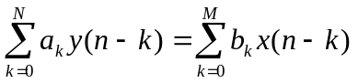 where a₀=1

The parameters of the LTI-system is the constant coefficients a_{k} k=1,2, …N and b_{k} k=1,2, …M.

The difference equation describes how you compute the output value y(n) from past output and input values y(n-k) respectively x(n-k) and the input value x(n).
The difference equation can be solved in the time domain (the direct method) by adding the homogenous solution y_{H}(n) and the particular solution y_{P}(n), i.e. y(n) = y_{H}(n) + y_{P}(n).
The indirect method uses the Z-transform to solve the difference equation.

Systems and signals in this course are described by a rational z-transforms R(z) according to:

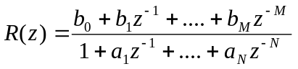,

that is as a ratio of two polynomials in z⁻¹.
A common method to compute the inverse transform r(n)=Z⁻¹{R(z)} is by partial-fraction expansion and the use of table lookup.

The Matlab-command [A,p,c]=residuez(b,a), where b= [b₀ b₁ …b_{M}] and a=[1 a₁ … a_{N}], does the partial-fraction expansion of a rational z-transform R(z) according to:

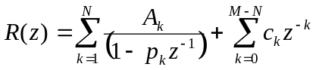

Questions.
A relaxed LTI-system is described by the difference equation:

y(n) - y(n-1) + 0.5y(n-2) = x(n) .

The system function H(z) and the impulse response h(n).
1) Use “paper and pen” to compute H(z)=Y(z)/X(z) from the difference equation and h(n) by using the partial-fraction expansion method and table lookup.
Also plot the pole-zero plot describing H(z).

2) Use Matlab and table lookup to:
Find the poles and zeros (=roots) of H(z) by the command roots.
Plot the pole-zero plot of H(z) use zplane(b,a).
Compute h(n)=Z⁻¹{H(z)} by using the command residuez and table lookup.

Question 1.
Explain the mathematical expression of h(n) from the pole-zero plot of H(z).
Is the system BIBO stable? Motivate your answer.

The output signal Y(z) and y(n).
1) Use “paper and pen” to compute Y(z) from the difference equation when the input signal x(n)=u(n) and y(n)= Z⁻¹{Y(z)} by using the partial-fraction expansion method and table lookup.

2) Use Matlab and table lookup to:
Compute y(n)=Z⁻¹{Y(z)} by using the command residuez and table lookup.
Find the poles and zeros (=roots) of H(z), X(z), and Y(z) by the command roots.
Plot the pole-zero plot of H(z), X(z), and Y(z) use subplot and zplane(b,a).

Question 2.
How is the pole-zero plot of Y(z) generated from the pole-zero plots of X(z) and H(z)?
Explain the mathematical expression of y(n) from the pole-zero plot of Y(z).

